Stat 350

Homework #2 Name:____________________________

**Due Tuesday March 1st by 12:00 pm**

1. The data in the table below resulted from an experiment that utilized a completely randomized design.

|  |  |  |
| --- | --- | --- |
| Treatment1 | Treatment2 | Treatment3 |
| 3.9 | 5.4 | 1.3 |
| 1.4 | 2.0 | 0.7 |
| 4.1 | 4.8 | 2.2 |
| 5.5 | 3.8 |  |
| 2.3 | 3.5 |  |
| C=17.2 | C=19.5 | C=4.2 |

a) Use the information in the table above and the summary statistics below to find the three missing values in the ANOVA table. **Use the formulas in your notes (subtraction method does not count as formula) and show your work**.

|  |  |  |  |
| --- | --- | --- | --- |
| **Column** | **n** | **Mean** | **Std. dev** |
| Treatment1 | 5 | 3.44 | 1.6087262 |
| Treatment2 | 5 | 3.9 | 1.3076697 |
| Treatment3 | 3 | 1.4 | 0.75498344 |

**ANOVA table**

|  |  |  |  |  |  |
| --- | --- | --- | --- | --- | --- |
| **Source** | **df** | **SS** | **MS** | **F-Stat** | **P-value** |
| Treatments | 2 | 12.4203 | 6.2101538 | 3.3876 | 0.0753 |
| Error | 10 | 18.332 | 1.8332 |  |  |
| Total | 12 | 30.752308 |  |  |  |

SS(Treatments) where G = 40.9 and N = 13

So that SS(Treatments) = 

MS(Error) = 18.332/10= 1.8332

F-Stat = 6.2101538/1.8332=3.3876

2. Complete textbook problem #10.34 on page 495 and the follow-up problem #10.57 on page 505. Conduct a complete analysis including stating the null and alternative hypothesis statements, defining all parameters, assumption checks and a post-hoc test if necessary. The data set is DRINKERS on STATCRUNCH chapter 10.

This is a completely randomized designed experiment as the students were randomly assigned to one of the four treatment groups in order to determine if there was a difference in the mean number of responses in each of the groups.

Ho: The mean task score for all four groups is the same

Ha: At least two of the group mean task scores are different

**Assumption Checks:**

1) Students were randomly assigned to the four groups

2) The variance of the four groups is the same as shown by the high p-value found using Levene’s Test for Homogeneity of Variance.

**Levene's Test for Homogeneity of Variance**

| **Test Statistic** | **DF 1** | **DF 2** | **P-value** |
| --- | --- | --- | --- |
| 0.77986072 | 3 | 40 | 0.5122 |

3) The QQ plot of the residuals indicates some **cause for concern as the points do not follow a linear pattern but as ANOVA is robust to slight deviations from normality we will procede.**

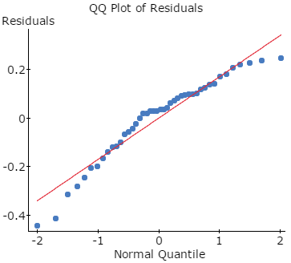

**Analysis of Variance results:**  
Responses: SCORE  
Factors: GROUP  
  
**Response statistics by factor**

| **GROUP** | **n** | **Mean** | **Std. Dev.** | **Std. Error** |
| --- | --- | --- | --- | --- |
| A | 11 | 0.063636364 | 0.2180492 | 0.065744308 |
| AC | 11 | 0.26545455 | 0.15260168 | 0.046011138 |
| AR | 11 | 0.44 | 0.17052859 | 0.051416304 |
| P | 11 | 0.4 | 0.15251229 | 0.045984187 |

**ANOVA table**

| **Source** | **DF** | **SS** | **MS** | **F-Stat** | **P-value** |
| --- | --- | --- | --- | --- | --- |
| GROUP | 3 | 0.95064545 | 0.31688182 | 10.290649 | <0.0001 |
| Error | 40 | 1.2317273 | 0.030793182 |  |  |
| Total | 43 | 2.1823727 |  |  |  |

As the p-value is very small, less than 0.0001, we can reject the null hypothesis and conclude that the mean task score for all four groups is not the same.

10.57 follow-up

**Tukey HSD results (95% level)**  
A subtracted from

|  | **Difference** | **Lower** | **Upper** | **P-value** |
| --- | --- | --- | --- | --- |
| AC | 0.20181818 | 0.001256169 | 0.40238019 | 0.0481 |
| AR | 0.37636364 | 0.17580162 | 0.57692565 | <0.0001 |
| P | 0.33636364 | 0.13580162 | 0.53692565 | 0.0003 |

AC subtracted from

|  | **Difference** | **Lower** | **Upper** | **P-value** |
| --- | --- | --- | --- | --- |
| AR | 0.17454545 | -0.026016558 | 0.37510747 | 0.1076 |
| P | 0.13454545 | -0.066016558 | 0.33510747 | 0.2892 |

AR subtracted from

|  | **Difference** | **Lower** | **Upper** | **P-value** |
| --- | --- | --- | --- | --- |
| P | -0.04 | -0.24056201 | 0.16056201 | 0.9501 |

The results of Tukey HSD show that the alcohol group is significantly different from all of the other groups as all pairwise comparisons are different. However, there is no difference between the other three groups as all p-value are larger than 0.05. This shows that caffeine and rewards are no better than a placebo.

3. Complete textbook problem #10.35 on page 496. Conduct a complete analysis including stating the null and alternative hypothesis statements, defining all parameters, assumption checks and a post-hoc test if necessary. See question 10.54 page 505 to help with your follow-up question. Dataset is HONEYCOUGH on STATCRUNCH chapter 10.

This is a designed experiment is cold treatment was ‘assumed” randomly assigned to each of the household for their children.

Ho: The mean improvement is the same for the three groups.

Ha: the mean improvement is different for at least two of the groups.

Assumption Checks:

1) The treatment was randomly assigned to the three groups.

2) The variance between the three groups is the same.

**Levene's Test for Homogeneity of Variance**

| **Test Statistic** | **DF 1** | **DF 2** | **P-value** |
| --- | --- | --- | --- |
| 0.92182558 | 2 | 102 | 0.4011 |

3) The QQ plot of the residuals shows the probability distributions of the populations of responses associated with each treatment are normal

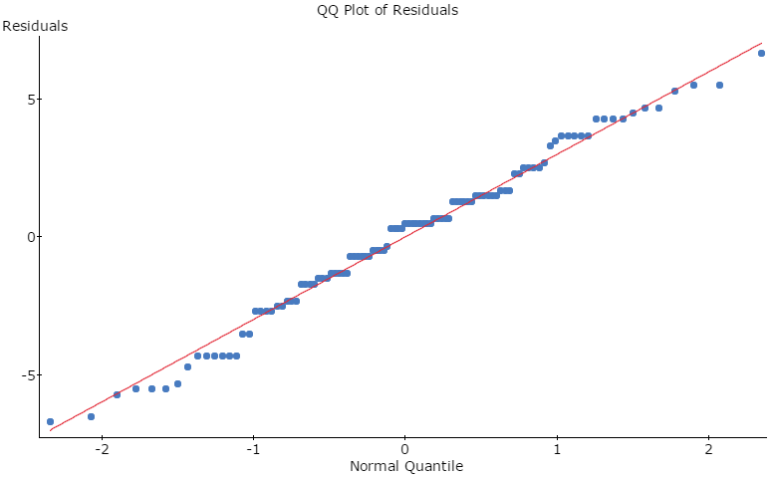

**ANOVA table**

| **Source** | **DF** | **SS** | **MS** | **F-Stat** | **P-value** |
| --- | --- | --- | --- | --- | --- |
| Treatment | 2 | 318.50914 | 159.25457 | 17.509567 | <0.0001 |
| Error | 102 | 927.71943 | 9.0952886 |  |  |
| Total | 104 | 1246.2286 |  |  |  |

As the p-value is small, less than 0.05, we reject the null hypothesis. There is evidence that the mean improvement scores between the three groups is not the same.

**Tukey HSD results (95% level)**  
C subtracted from

|  | **Difference** | **Lower** | **Upper** | **P-value** |
| --- | --- | --- | --- | --- |
| DM | 1.8198198 | 0.10236253 | 3.5372771 | 0.0352 |
| H | 4.2007722 | 2.5094509 | 5.8920935 | <0.0001 |

DM subtracted from

|  | **Difference** | **Lower** | **Upper** | **P-value** |
| --- | --- | --- | --- | --- |
| H | 2.3809524 | 0.64051572 | 4.121389 | 0.0044 |

The Tukey HSD test shows that control improvement score is statistically different from both the DM and honey group and the DM improvement score is statistically different from the honey group. By examining the means of the three groups, honey had the highest mean improvement score.

**Response statistics by factor**

| **Treatment** | **n** | **Mean** | **Std. Dev.** | **Std. Error** |
| --- | --- | --- | --- | --- |
| C | 37 | 6.5135135 | 2.9403479 | 0.48339021 |
| DM | 33 | 8.3333333 | 3.2564039 | 0.56686717 |
| H | 35 | 10.714286 | 2.8550412 | 0.48259005 |

4. Complete textbook example problem #10.96 on page 536. Conduct a complete analysis including stating the null and alternative hypothesis statements, defining all parameters, assumption checks and a post-hoc test if necessary.

Hypotheses Statements

Ho : The factors of Song Type and Pool do not interact to affect the response mean score

Ha :The factors Song Type and Pool do interact to affect the response mean score

Ho : There is no difference between the mean scores for the Song Types.

Ha : There is a difference between the mean score for the Song Type.

Ho : There is no difference between the mean score for the Pool group .

Ha : There is a difference between the mean score for the Pool group.

Assumption Checks:

1. Random and independent samples of experimental units are associated with each treatment.

Yes, we are assuming that subjects were independently and randomly selected assigned to the treatment groups.

2) The residuals should be normally distributed with mean zero.

Yes, the QQ plot of the residuals confirms normality assumption.

3) The response variance is constant for all treatment combinations.

**Note – Levene’s Test for 2-wat not available on StatCrunch so must examine scatterplot of residuals vs fitted values

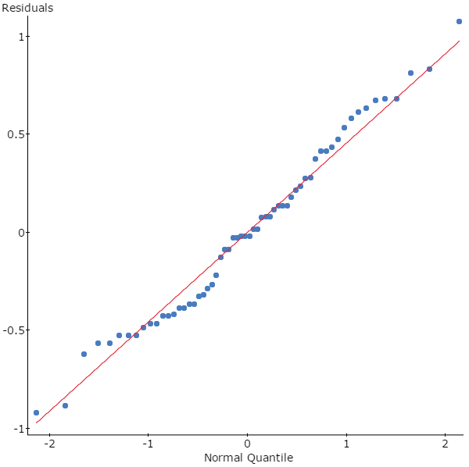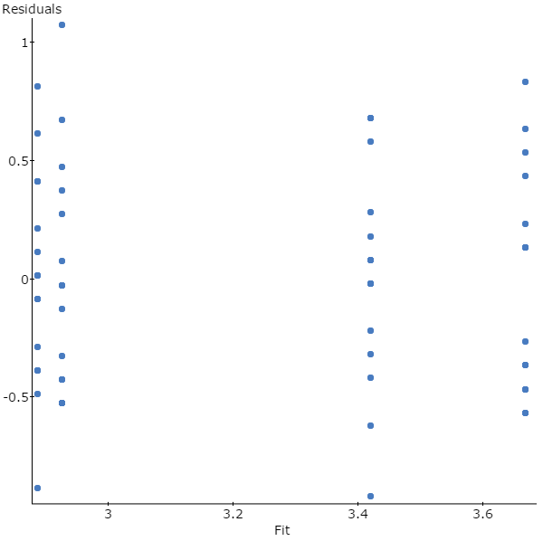

**ANOVA table**

| **Source** | **DF** | **SS** | **MS** | **F-Stat** | **P-value** |
| --- | --- | --- | --- | --- | --- |
| Song | 1 | 6.0801667 | 6.0801667 | 27.763318 | <0.0001 |
| Pool | 1 | 0.16016667 | 0.16016667 | 0.73135464 | 0.3961 |
| Interaction | 1 | 0.30816667 | 0.30816667 | 1.4071537 | 0.2405 |
| Error | 56 | 12.264 | 0.219 |  |  |
| Total | 59 | 18.8125 |  |  |  |

As the p-value for both the test for interaction and Pool are larger than 0.05, we fail to reject the null hypothesis for those test. However, the p-value is very low for song type, <0.001 so we reject the null hypothesis and can conclude that there is evidence that there is a difference between the mean score for the Song Type.

As there are only two song types we can examine the mean scores for the two types of songs to determine that the mean score for the ‘violent’ group of 3.54 is larger than the mean score for the ‘non-violent’ group of 2.90. See response plot below.

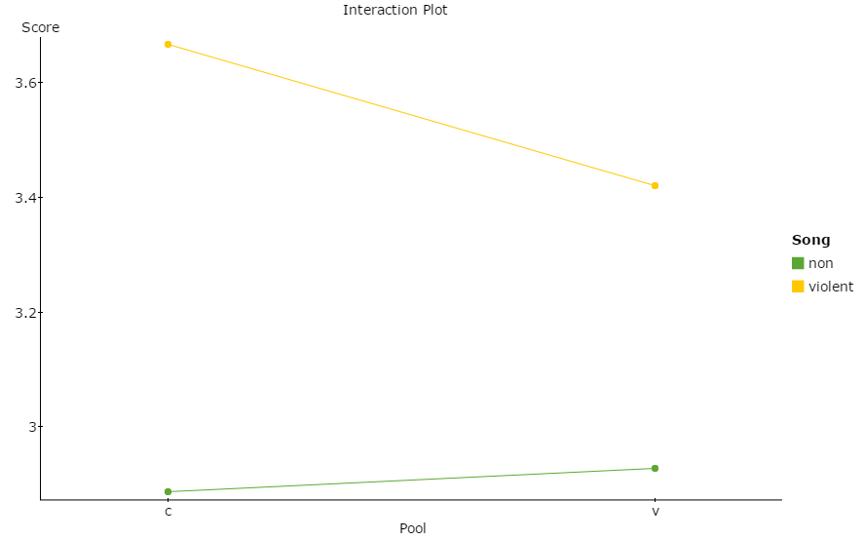

5. Suppose we wish to consider the effect of two factors on blood pressure. Factor A is diabetes with two levels and Factor B is weight with two levels. Ten diabetics (half of which are overweight) and ten non-diabetics (half of which are overweight) are randomly selected. None of the twenty participants was on medication for blood pressure. The diastolic blood pressure for the twenty subjects is given below. We are interested in the interaction of weight and diabetes.

|  |  |  |
| --- | --- | --- |
|  | **Normal Weight** | **Overweight** |
| **Non-diabetic** | 75,80,83,85,65 | 85,80,90,95,88 |
| **Diabetic** | 85,90,95,90,86 | 90,95,100,105,110 |

**Conduct a complete analysis of the data** to help the researchers answer their questions.

Hypotheses Statements

Ho : The factors of diabetic status and weight do not interact to affect the response mean

Ha :The factors diabetic status and weight do interact to affect the response mean

Ho : There is no difference between the mean BP for the diabetic status.

Ha : There is a difference between the mean BP for the diabetic status.

Ho : There is no difference between the mean BP for weight status .

Ha : There is a difference between the mean BP for weight status.

Assumption Checks:

1. Random and independent samples of experimental units are associated with each treatment.

Yes, we are assuming that subjects were independently and randomly selected.

2) The residuals should be normally distributed with mean zero.

Yes, the QQ plot of the residuals confirms normality assumption.

3) The response variance is constant for all treatment combinations.

Levene’s Test with a p-value =0.596 shows no evidence that the variances are not the same for all treatments.

**Note – Levene’s Test for 2-wat not available on StatCrunch so must examine scatterplot of residuals vs fitted values





**ANOVA: BP versus STATUS, WEIGHT**

Factor Type Levels Values

STATUS fixed 2 no, yes

WEIGHT fixed 2 normal, over

Analysis of Variance for BP

Source DF SS MS F P

STATUS 1 720.00 720.00 16.62 0.001

WEIGHT 1 540.80 540.80 12.48 0.003

STATUS*WEIGHT 1 0.80 0.80 0.02 0.894

Error 16 693.20 43.33

Total 19 1954.80

As the p-value of 0.894 is very large, more than 0.05, there is no evidence of interaction between diabetic status and weight. However, both factors are significant p-values <0.001. As there are only two levels of each factor we can see by the main effects plot that BP is lower normal weigh and non-diabetic.



As the p-value of 0.001 is very small, less than 0.05, there is evidence of interaction between diabetic status and weight. Therefore, main effects cease to have much meaning. The greatest mean BP. Note that the combination of overweight and diabetic produces the highest mean BP.